CS422 Lab 3 Report Structure

Juan Florez 039614388

Part I: Build Client-Server over Socket Programming
- From the code, how can you tell this socket is using TCP?
The socket is created using the function call socket(AF_INET, SOCK_STREAM, 0) in both client.c and server.c. The SOCK_STREAM parameter indicates TCP, as it specifies a stream-oriented, reliable, connection-based protocol (unlike SOCK_DGRAM for UDP)
- What are the IP addresses of the two lab machines you used? Are they public or private IPs?
amber01.cs.purdue.edu: 10.168.53.10 and amber05.cs.purdue.edu: 10.168.53.14
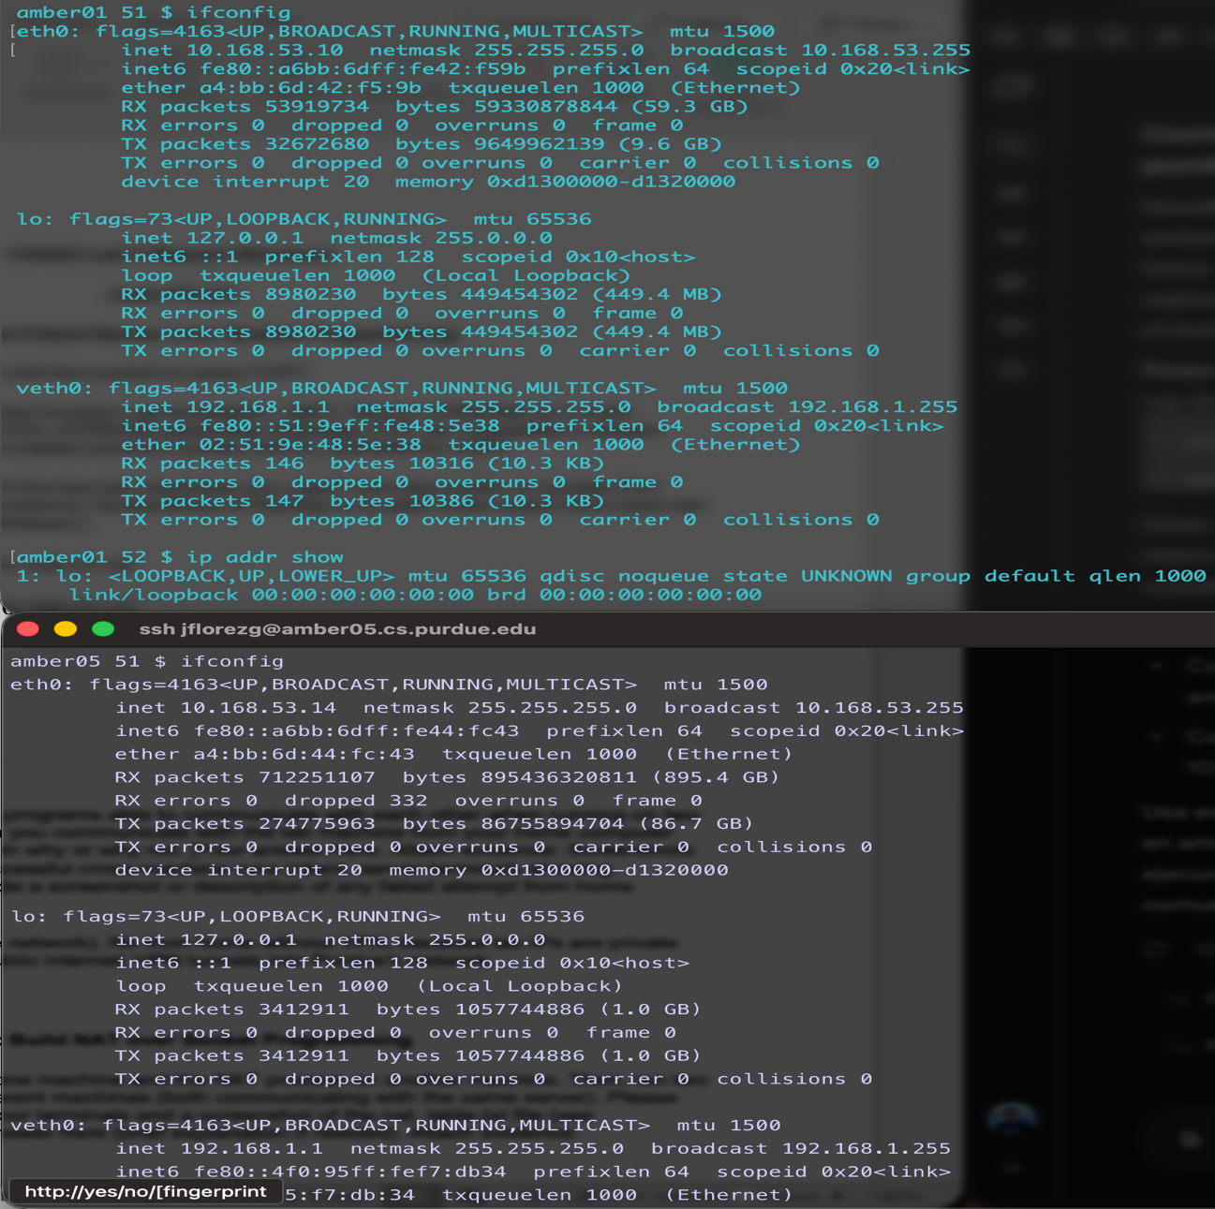

- Were your client and server programs able to communicate with each other when running on two different lab machines? Can you communicate with the lab machine from your home computer without Purdue VPN? Explain why or why not.
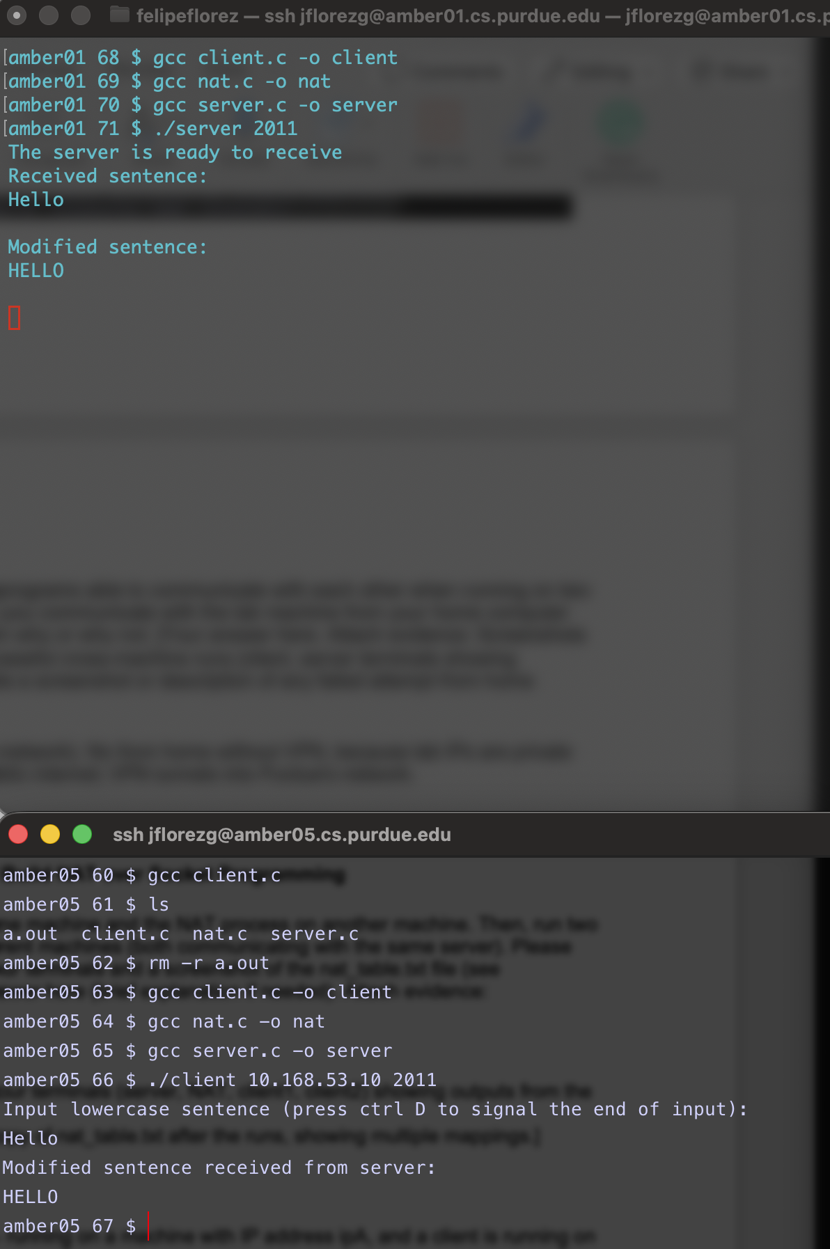
➜ lab3-NAT 👾 ./client 10.168.53.10 2011
Input lowercase sentence (press ctrl D to signal the end of input):
gsdgfdsg
Connection Failed

Yes for lab machines (same network). No from home without VPN, because lab IPs are private and not routable over the public internet; VPN tunnels into Purdue's network.

Part II: Build NAT over Socket Programming
- Run the server process on one machine and the NAT process on another machine. Then, run two client processes on two different machines (both communicating with the same server). Please include screenshots of the four terminals and a screenshot of the nat_table.txt file (see sample_output.txt).
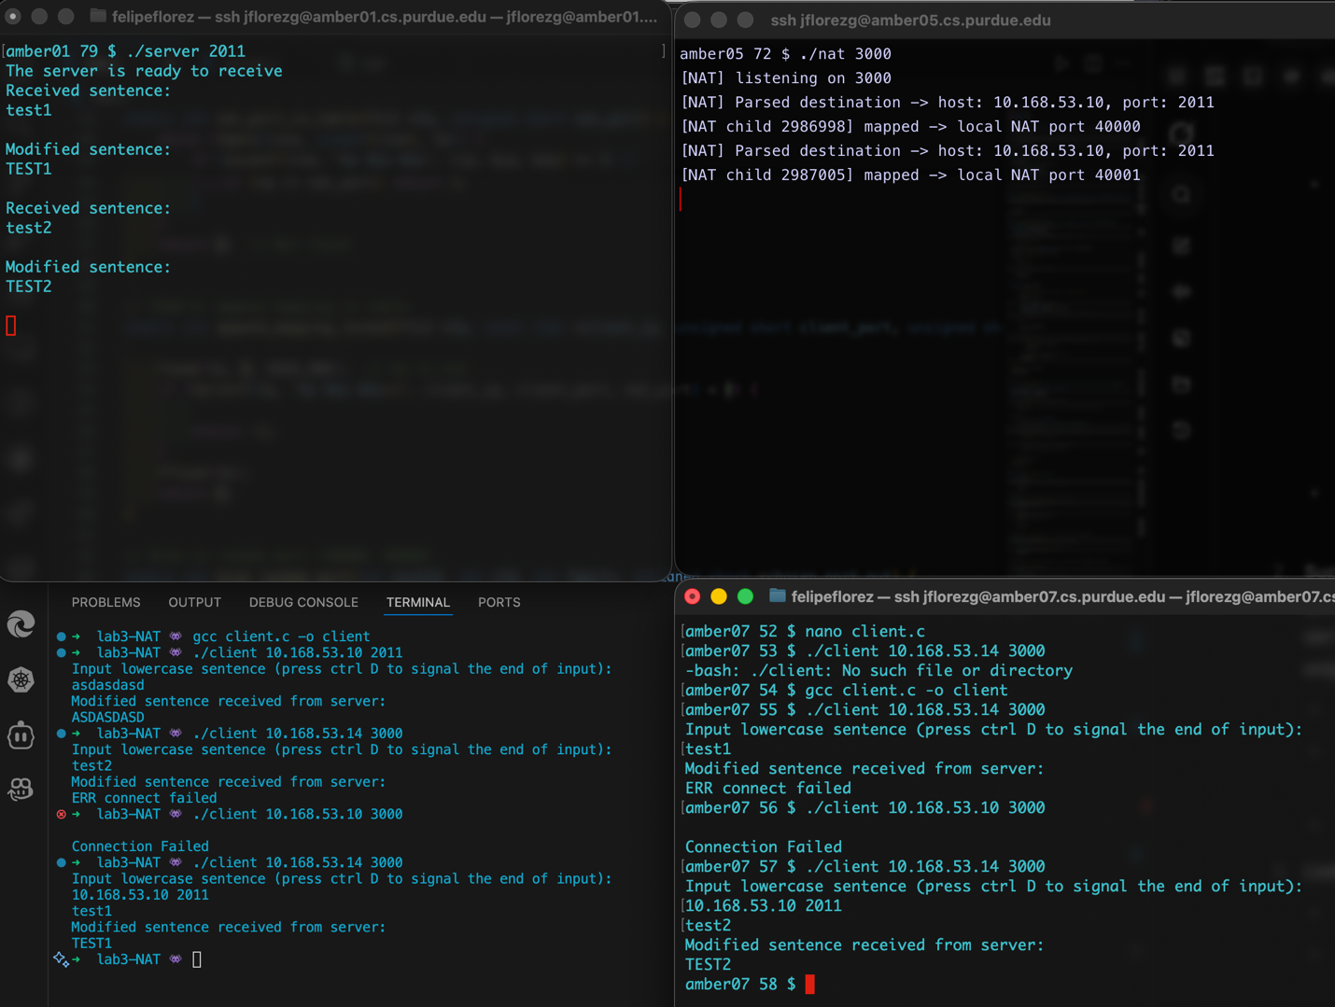
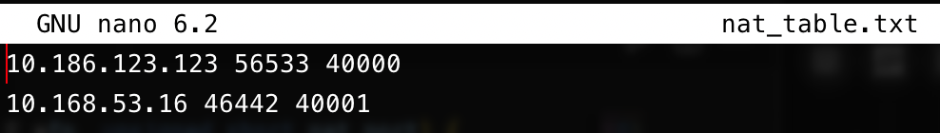
- Suppose the NAT process is running on a machine with IP address ipA, and a client is running on a machine with IP address ipB. When the server eventually receives a message from the client, what is the source IP address shown on the server side?
ipA (NAT's IP). NAT replaces client's ipB with its own when forwarding.

- List at least two advantages of using NAT.
- NAT conserves public IPv4 addresses by allowing multiple private devices to share a single public IP, helping mitigate IPv4 address exhaustion.
- NAT provides a layer of security by hiding internal private IP addresses from the external network, making it harder for outsiders to directly access or scan internal devices.

- In practice, how does a newly joined private client discover the IP address of the router running NAT?
A newly joined private client typically discovers the NAT router's IP address through DHCP. When the client connects to the network, it broadcasts a DHCP request, and the router responds with an IP assignment, including the router's IP as the default gateway.
- When two different private clients send messages to the same public server, how does the NAT device distinguish between their connections?
The NAT device distinguishes between connections using Port Address Translation , where it assigns unique source ports to each client's outgoing connection. It maintains a mapping table of internal IP/port to external NAT IP/port, allowing it to route incoming responses back to the correct client based on the destination port.

